Visualization Tool for Electric Vehicle Charge and Range Analysis

1. Introduction
The rapid growth of Electric Vehicles (EVs) has transformed the global transportation industry. Governments and companies are investing heavily in EV technology to reduce carbon emissions and dependence on fossil fuels. However, understanding EV market trends, charging infrastructure, vehicle performance, and pricing requires effective data analysis and visualization.
This project focuses on analyzing Electric Vehicle data using Tableau. The aim is to convert raw EV-related data into meaningful insights through interactive dashboards and visualizations. The project demonstrates the complete data analytics workflow including problem identification, data collection, data cleaning, visualization creation, and result interpretation.

2. Problem Statement
With the increasing number of Electric Vehicles worldwide, there is a need to understand important factors such as:
• Availability of EV charging stations
• Distribution of EV infrastructure across regions
• Performance comparison of EV brands
• Pricing differences among EV models
• Efficiency and powertrain variations
Raw data alone cannot easily reveal patterns or trends. Therefore, data visualization tools such as Tableau are required to transform raw datasets into interactive dashboards that help users explore and understand the data.

3. Objectives of the Project
The main objectives of this project are:
• To collect and analyze Electric Vehicle datasets
• To clean and preprocess the data for accurate analysis
• To create meaningful visualizations using Tableau
• To develop interactive dashboards and worksheets
• To identify trends and insights related to EV infrastructure and vehicles
• To present results in a clear and understandable format

4. Data Collection
The dataset used in this project contains information related to Electric Vehicles and EV charging infrastructure. The data includes attributes such as:
• EV brand names
• Vehicle models
• Price of EV vehicles
• Top speed of vehicles
• Powertrain types
• Body style of vehicles
• Charging stations distribution by region
• EV efficiency and performance indicators
The data was collected from publicly available datasets and online EV databases. After collecting the dataset, it was stored in a structured format for further analysis.

5. Data Cleaning and Preprocessing
Raw data often contains missing values, inconsistent formats, and duplicate entries. Before visualization, the dataset must be cleaned.
The following steps were performed:
• Removal of duplicate records
• Handling missing values
• Standardizing data formats
• Correcting inconsistent category names
• Filtering irrelevant columns
These preprocessing steps ensure that the data is accurate and suitable for analysis and visualization.

6. Data Visualization using Tableau
Tableau was used as the main visualization tool for this project. Tableau allows users to create interactive charts, maps, and dashboards.
The following worksheets were created:
• Charging Stations by Region and Type in India
• EV Charging Stations Map of India
• Different EV Cars in India
• Top Speed for Different Brands
• Price Comparison for EV Brands
• Top 10 Most Efficient EV Brands
• Brands by Body Style
• Brands Filtered by Powertrain Type
• Number of Models by Each Brand
• Summary Cards for EV Brands (Global and India)
Each worksheet highlights a specific aspect of EV data analysis.
i) Charging Stations by Region and Type in India;
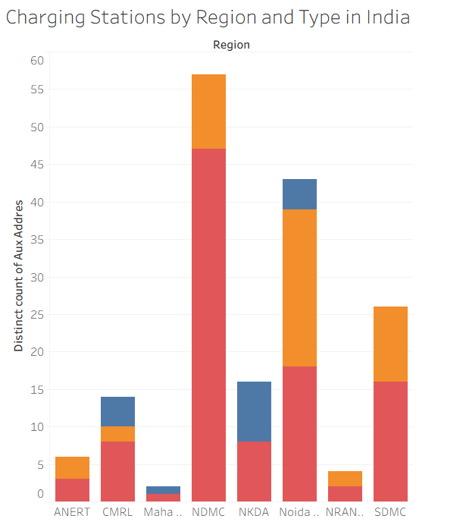
ii) EV Charging Stations in India
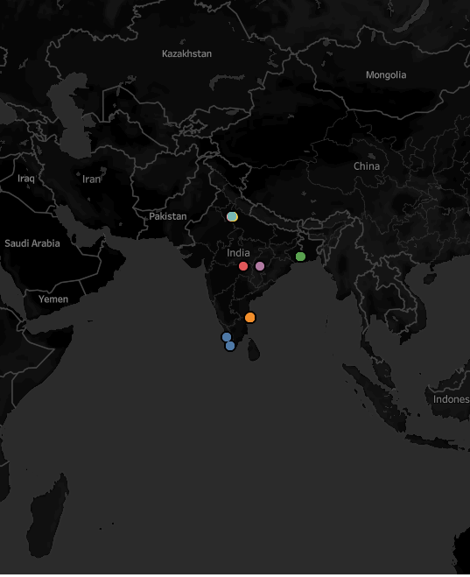
iii) Different EV Cars in India
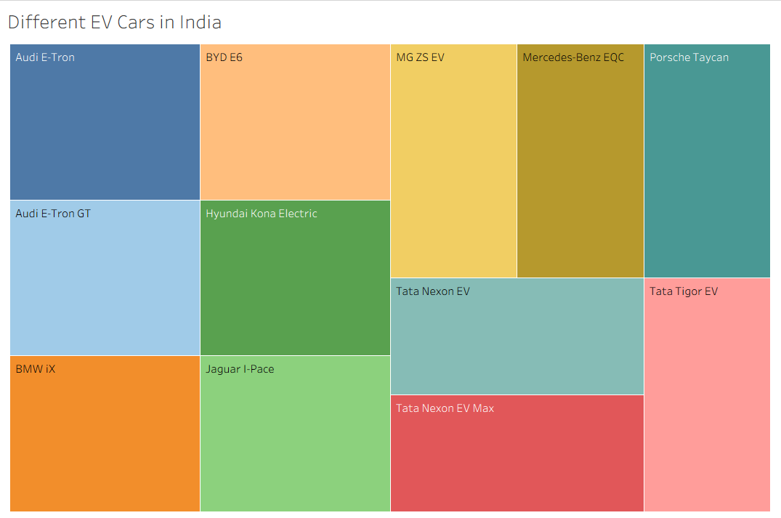
iv) Top Speed for Different Brands
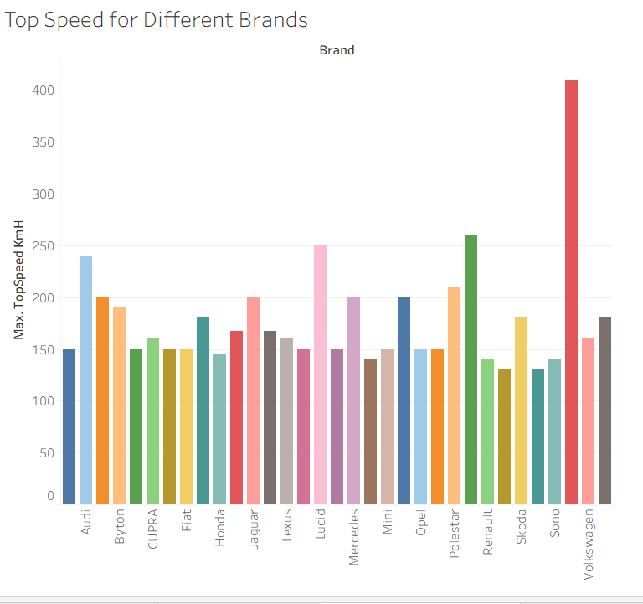

v) Price for Different Brands in India
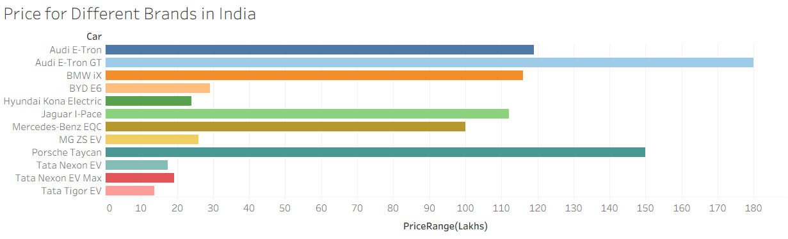
vi) Top 10 Most Efficient EV Brands
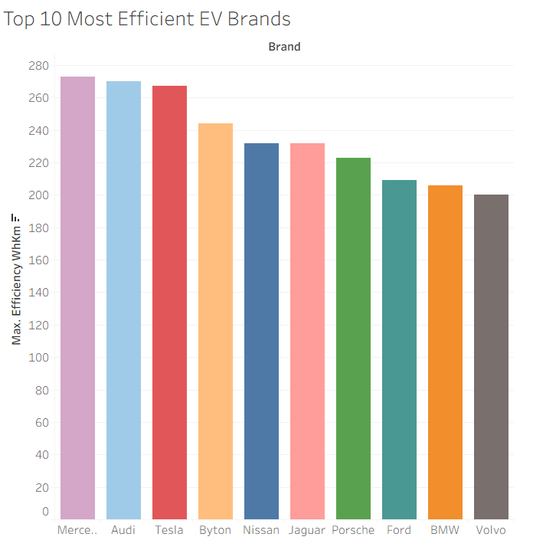

vii) Brands According to Body Style
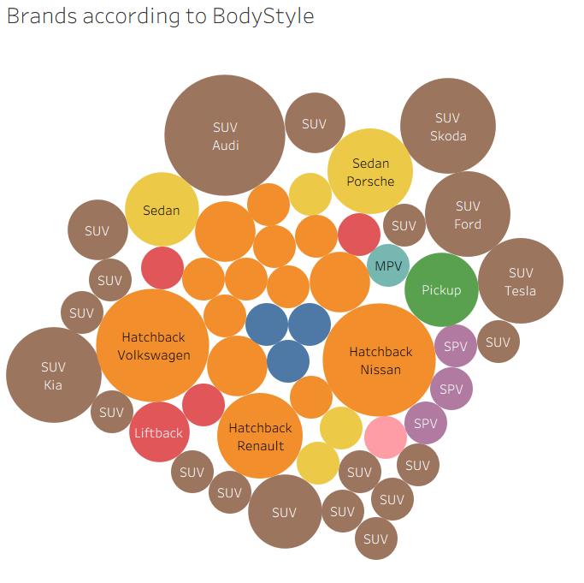
viii) Brands Filtered by PowerTrain Type
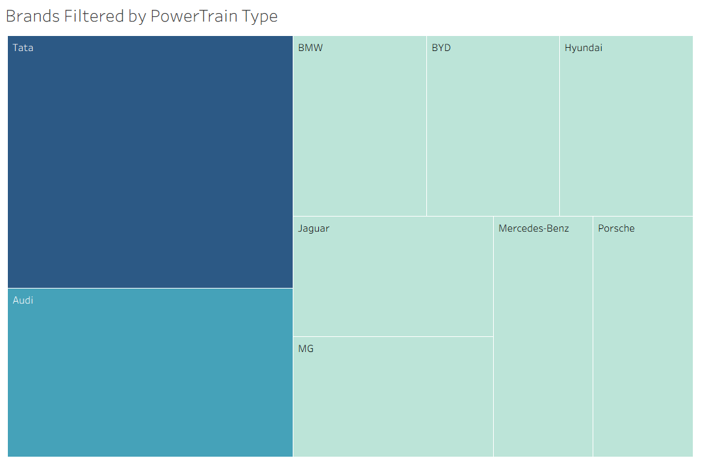

ix) No of Models by each Brand
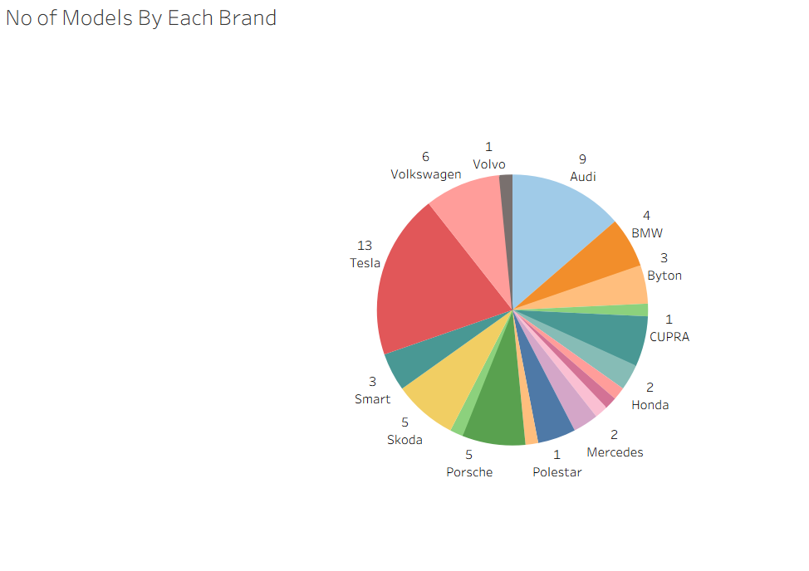
x) Summary Card for different brands of EV Cars Globally

xi) Summary Card for different brands of EV Cars in India

7. Dashboard Creation
After creating individual worksheets, dashboards were developed to combine multiple visualizations in a single interface.
The dashboards allow users to:
• Compare EV brands easily
• Analyze price differences
• Understand regional charging infrastructure
• Explore vehicle specifications
Interactive filters and controls were added so users can dynamically explore the data.
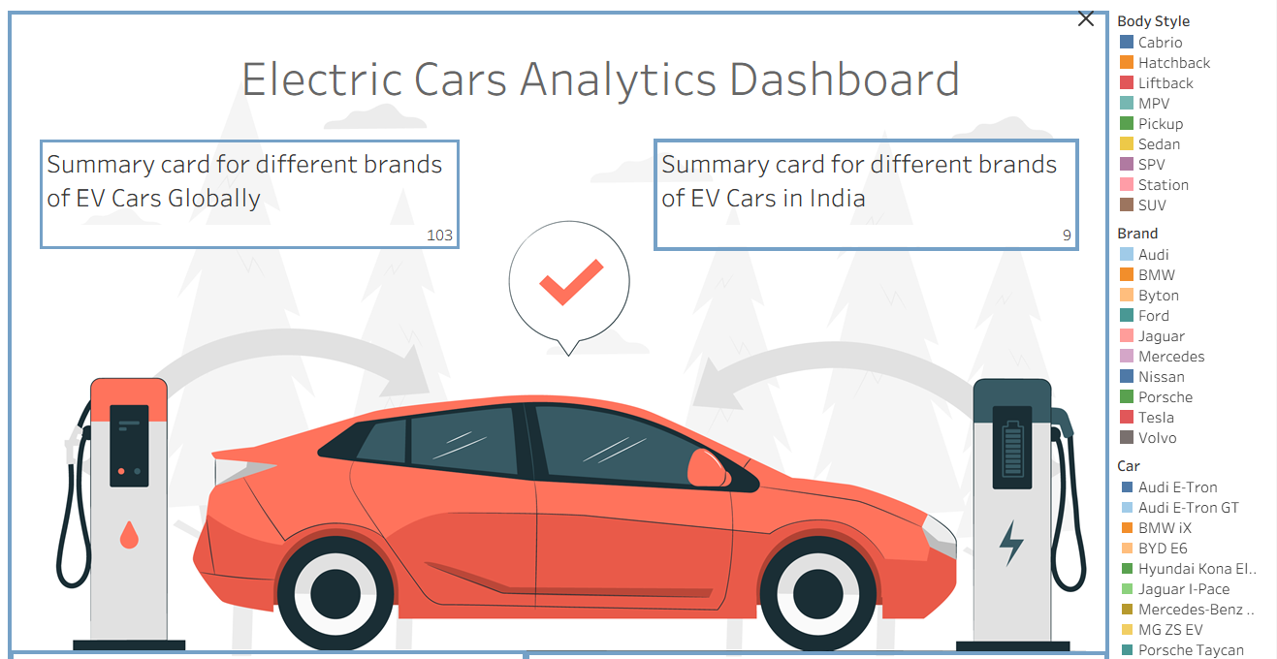
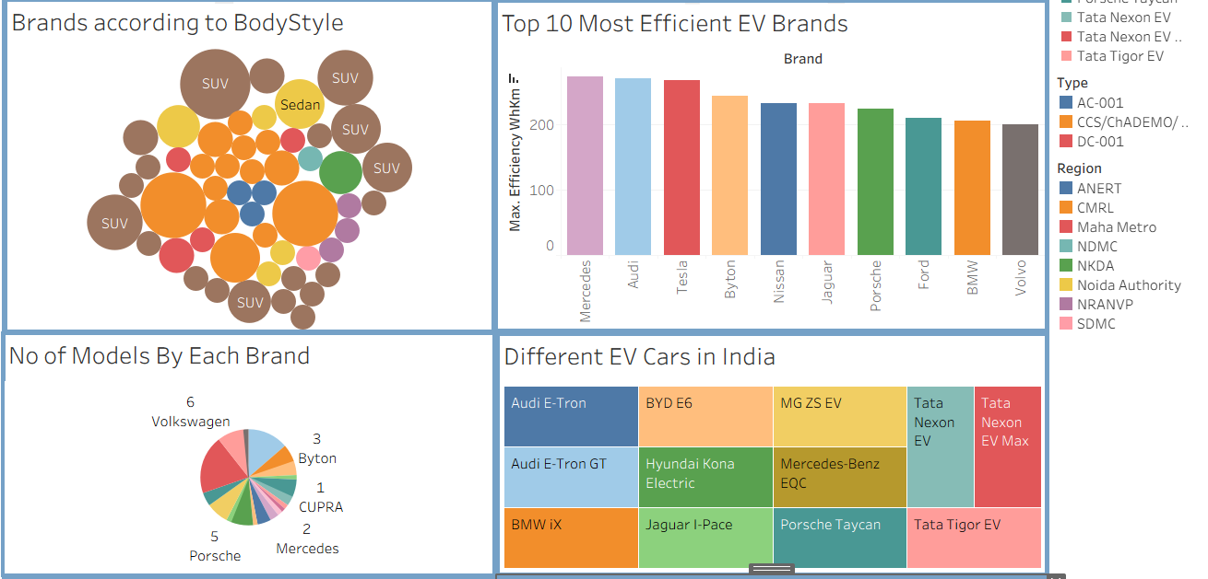
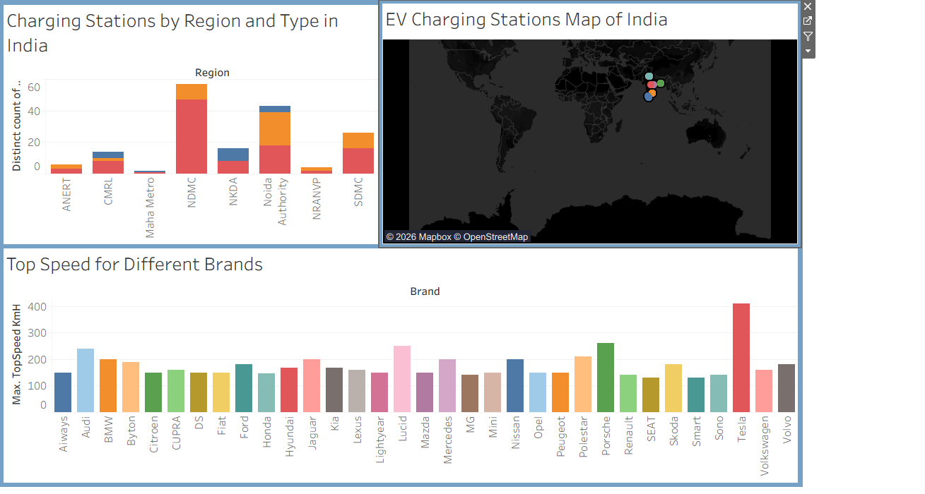

8. Analysis and Findings
Based on the visualizations and dashboards, several insights were identified:
• EV charging infrastructure is unevenly distributed across regions.
• Certain EV brands dominate the market in terms of number of models.
• Price varies significantly depending on brand and vehicle specifications.
• Some EV brands provide higher efficiency compared to others.
• The adoption of EVs is increasing steadily with better charging infrastructure.
These insights demonstrate how data visualization helps reveal hidden patterns in complex datasets.

9. Conclusion
This project successfully demonstrates the process of transforming raw Electric Vehicle data into meaningful visual insights using Tableau.
The project highlights the importance of:
• Data cleaning and preprocessing
• Effective visualization techniques
• Interactive dashboards for better understanding
The developed dashboards provide useful insights about EV infrastructure, vehicle performance, and market trends. This type of analysis can support decision-making for consumers, companies, and policymakers in the electric mobility sector.

10. Future Scope
This project can be expanded further by:
• Including real-time EV data
• Integrating machine learning models for prediction
• Adding more datasets related to EV sales and battery performance
• Developing a full web-based dashboard system for public use
Future improvements can make the analysis even more comprehensive and useful.

